Assignment 3
Lab: Python Parallel Programming
Akanksha Jadhao | 260740150004
Pratik Abhang | 260740150018

Exercise 1 — MPI Token Ring Communication
from mpi4py import MPI
comm = MPI.COMM_WORLD
rank = comm.Get_rank()
size = comm.Get_size()

if size < 3:
if rank == 0:
print("Please run with at least 3 MPI processes.")
raise SystemExit

next_rank = (rank + 1) % size
prev_rank = (rank - 1 + size) % size

if rank == 0:
token = {"hops": 0, "history": [0]}
token = comm.sendrecv(token, dest=next_rank, source=prev_rank)
print("Total hops:", token["hops"])
print("Traversal history:", token["history"])
else:
token = comm.recv(source=prev_rank)
token["hops"] += 1
token["history"].append(rank)
comm.send(token, dest=next_rank)
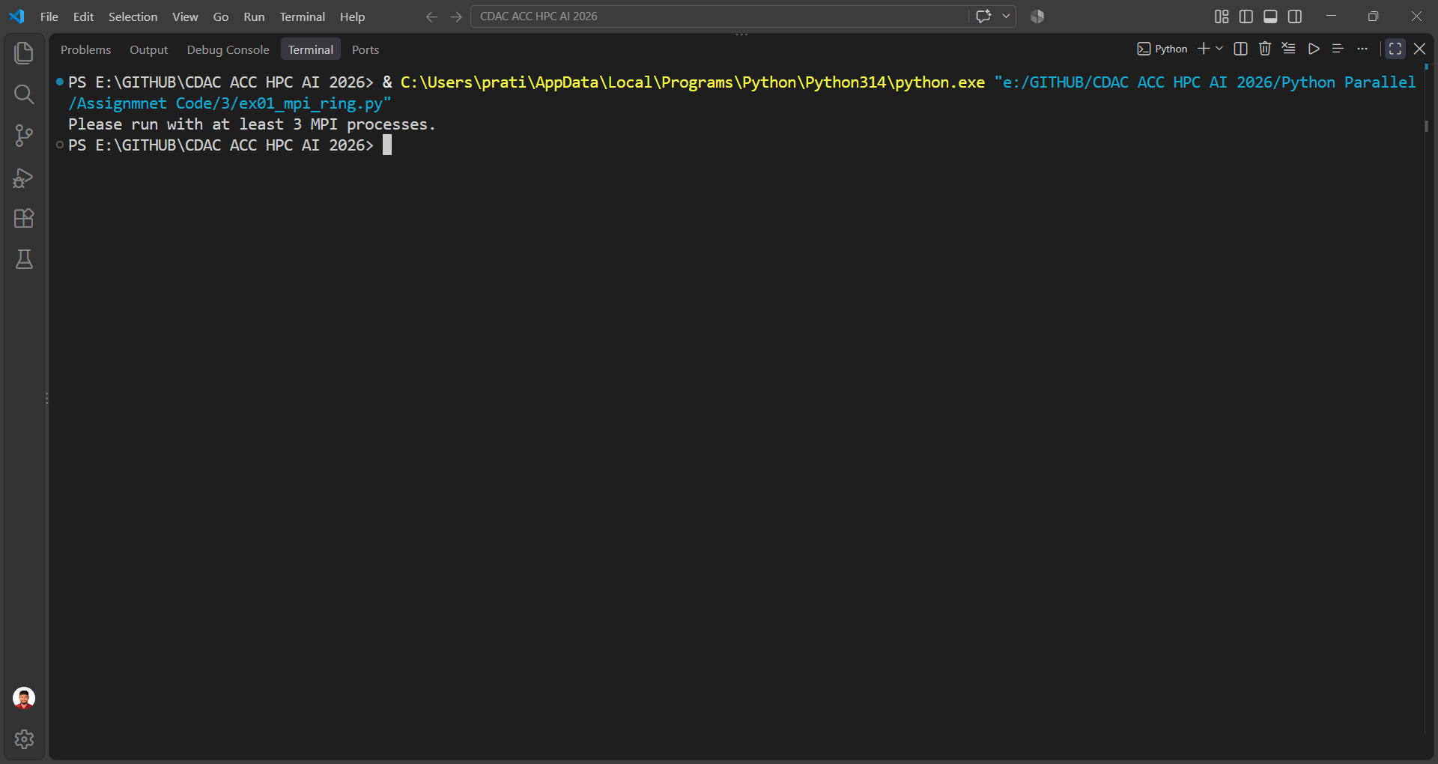

Exercise 2 — Distributed Monte Carlo Pi
from mpi4py import MPI
import random
import math

comm = MPI.COMM_WORLD
rank = comm.Get_rank()
size = comm.Get_size()

start = MPI.Wtime()

if rank == 0:
total_samples = 12_000_000
else:
total_samples = None

total_samples = comm.bcast(total_samples, root=0)
local_samples = total_samples // size

random.seed(rank * 100 + 42)

local_inside = 0
for _ in range(local_samples):
x = random.random()
y = random.random()
if x * x + y * y <= 1:
local_inside += 1

total_inside = comm.reduce(local_inside, op=MPI.SUM, root=0)

if rank == 0:
pi_approx = 4 * total_inside / (local_samples * size)
error = abs(pi_approx - math.pi)
runtime = MPI.Wtime() - start

print(f"Pi approximation: {pi_approx}")
print(f"Error: {error}")
print(f"Execution time: {runtime:.6f} seconds")
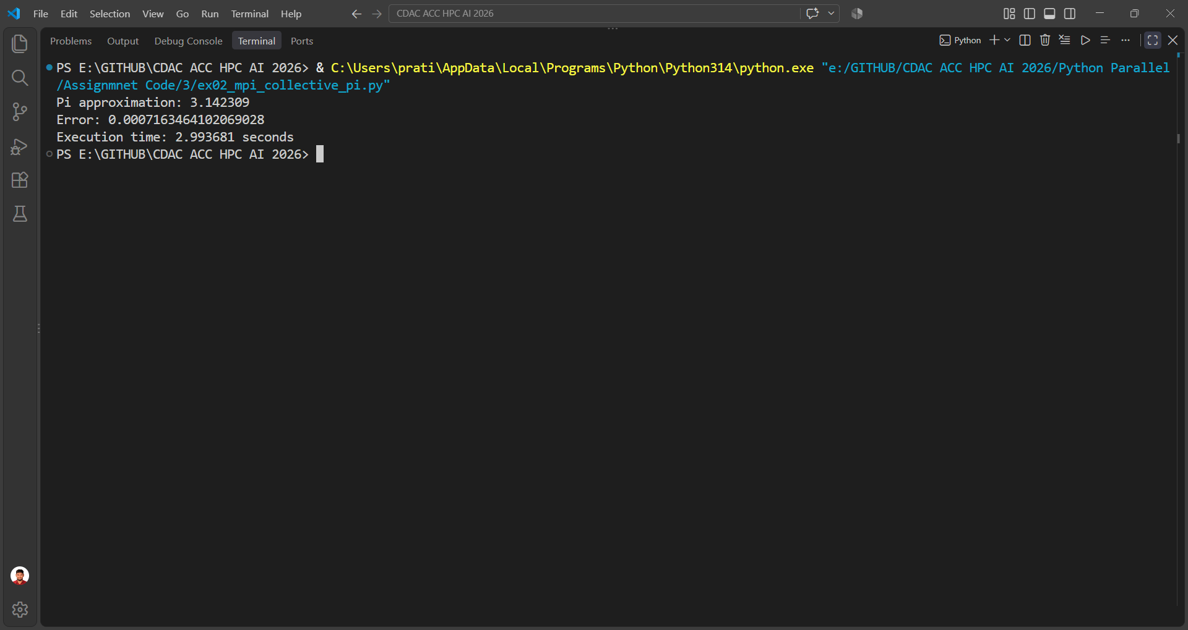

Exercise 3 — ThreadPoolExecutor Downloader
from concurrent.futures import ThreadPoolExecutor, as_completed, TimeoutError
import time

endpoints = [
("https://example.com/a", 0.2),
("https://example.com/b", 0.4),
("https://example.com/c", 0.6),
("https://example.com/d.error", 0.3),
("https://example.com/e", 0.8),
("https://example.com/f", 1.2),
("https://example.com/g", 1.5),
("https://example.com/h", 0.5),
("https://example.com/i.error", 0.7),
("https://example.com/j", 0.9),
]

def download_endpoint(url, delay):
time.sleep(delay)

if url.endswith(".error"):
raise ConnectionError(f"Connection failed: {url}")

payload = f"Downloaded payload from {url}"
return payload

with ThreadPoolExecutor(max_workers=5) as executor:
future_to_url = {
executor.submit(download_endpoint, url, delay): url
for url, delay in endpoints
}

for future in as_completed(future_to_url):
url = future_to_url[future]

try:
payload = future.result(timeout=1.0)
print(f"SUCCESS: {url} -> {len(payload.encode())} bytes")
except ConnectionError as exc:
print(f"ERROR: {url} -> {exc}")
except TimeoutError:
print(f"TIMEOUT: {url} took longer than 1 second")
except Exception as exc:
print(f"ERROR: {url} -> {exc}")
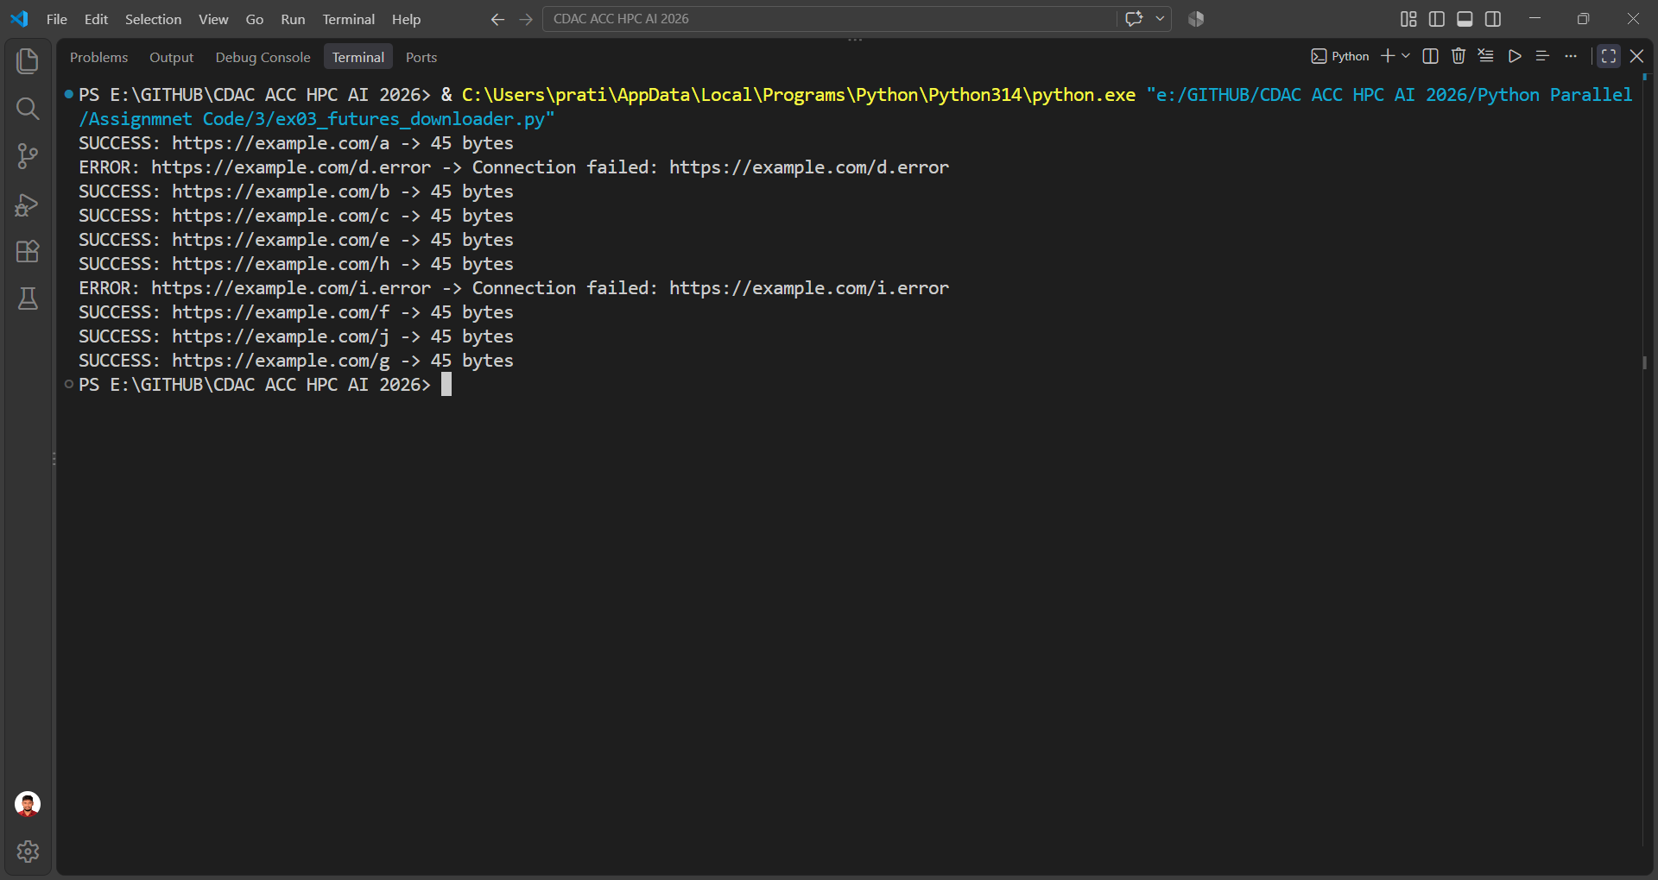

Exercise 4 — Asyncio Health Monitor
import asyncio
import time

async def check_database():
await asyncio.sleep(0.4)
return {"db": "HEALTHY", "latency_ms": 12}

async def check_redis_cache():
await asyncio.sleep(0.2)
return {"cache": "HEALTHY", "latency_ms": 4}

async def check_storage_service():
await asyncio.sleep(0.6)
return {"storage": "HEALTHY", "latency_ms": 28}

async def run_health_checks():
start = time.perf_counter()

results = await asyncio.gather(
check_database(),
check_redis_cache(),
check_storage_service(),
)

elapsed = time.perf_counter() - start

print("Health check results:")
for result in results:
print(result)

print(f"Total execution time: {elapsed:.3f} seconds")
print("Expected: approximately 0.6 seconds, not 1.2 seconds.")

asyncio.run(run_health_checks())
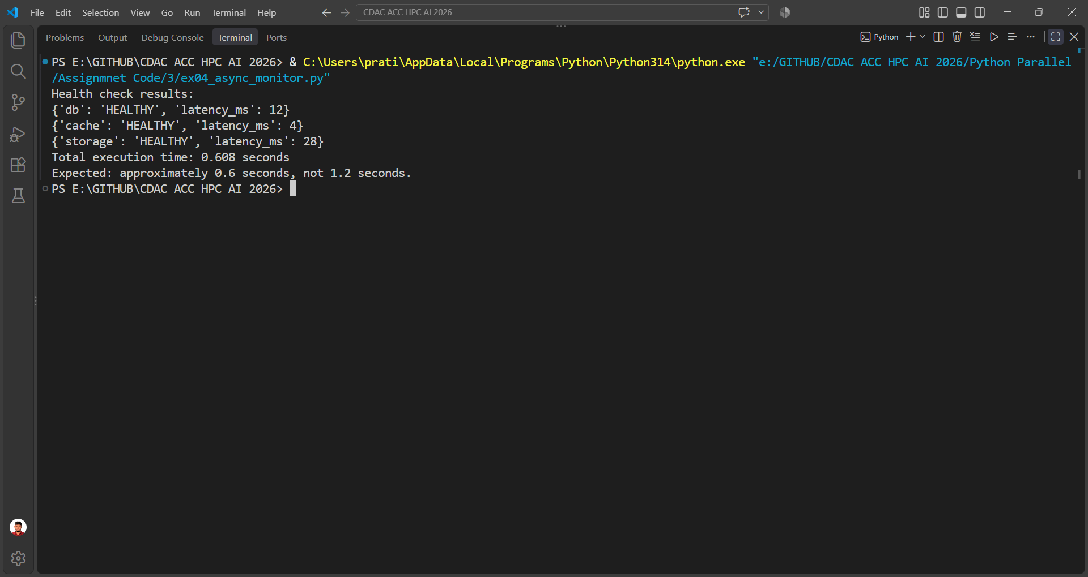

Exercise 5 — Asyncio with CPU Work
import asyncio

async def heartbeat_ticker():
try:
while True:
print("[Heartbeat] Active and responsive...")
await asyncio.sleep(0.25)
except asyncio.CancelledError:
print("[Heartbeat] Stopped cleanly.")
raise

def fibonacci_cpu(n):
a, b = 0, 1
for _ in range(n):
a, b = b, a + b
return a

async def main():
heartbeat_task = asyncio.create_task(heartbeat_ticker())

try:
loop = asyncio.get_running_loop()
result = await loop.run_in_executor(None, fibonacci_cpu, 35)
print("Fibonacci(35):", result)
finally:
heartbeat_task.cancel()
try:
await heartbeat_task
except asyncio.CancelledError:
pass

asyncio.run(main())
